Simple Linear Regression

Absolutely. Let’s learn Simple Linear Regression from the Machine Learning point of view, starting from the basic idea and going through all important formulas, a complete numerical example, graph, prediction, error, cost function, and evaluation.
📘 Simple Linear Regression

🧠 One-line memory trick
Simple Linear Regression = Find the best straight line between one X and one Y, using
$$\boxed{\hat{Y}=b_{0}+b_{1}X}$$
where slope $b_{1}$tells how much Y changes when X increases by 1, and intercept $b_{0}$tells the predicted Y when X = 0.

1. What is Regression?
Regression is a supervised machine learning technique used to predict a continuous numerical value.
Examples:
- Predict house price → ₹50 lakh
- Predict salary → ₹8.5 lakh
- Predict temperature → 32.5°C
- Predict marks → 85.4
In Simple Linear Regression, we have:
- One input variable (X)
- One output variable (Y)
Example:
Predict a student's marks based on the number of hours studied.
Hours Studied (X) | Marks (Y)
1 | 30
2 | 40
3 | 50
4 | 60
5 | 70
Here:
X = Hours studied
Y = Marks

2. Main Idea
We try to find the best straight line passing through the data points.
The line is:
$$\hat{Y}=b_{0}+b_{1}X$$
Where:
- $\hat{Y}$= predicted value of Y
- $b_{0}$= intercept
- $b_{1}$= slope/coefficient
- $X$= input
Simple meaning
$$\boxed{Prediction=Intercept+Slope×Input}$$

3. What does the line mean?
Suppose our model is:
$$\hat{Y}=20+10X$$
Here:
Intercept = 20
When:
$$X=0$$
then:
$$Y=20$$
So the line starts at 20 on the Y-axis.
Slope = 10
For every 1 unit increase in X, Y increases by 10.
For example:
$$X=3 \\ Y=20+10\left(3\right)=50$$
So predicted marks = 50.

4. Graph
The important idea is that the original observations are points, and regression finds the best-fit straight line.
R² = 0.72 · b₀ = intercept · b₁ = slope · least squares minimizes squared vertical residual gaps.
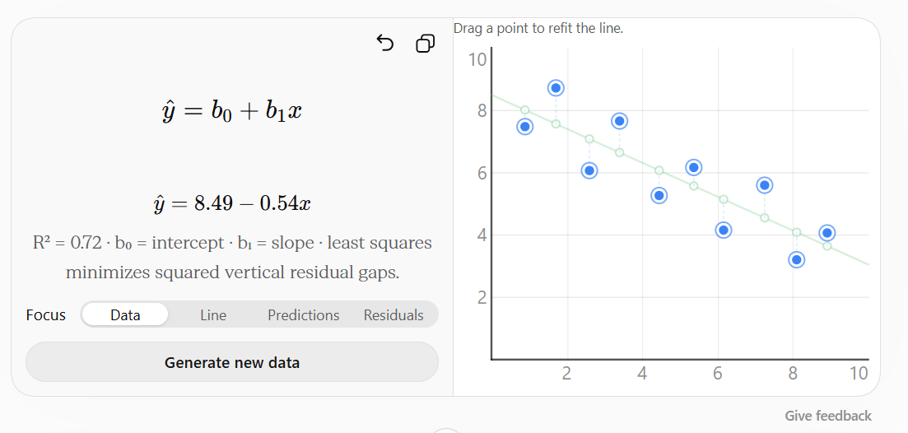
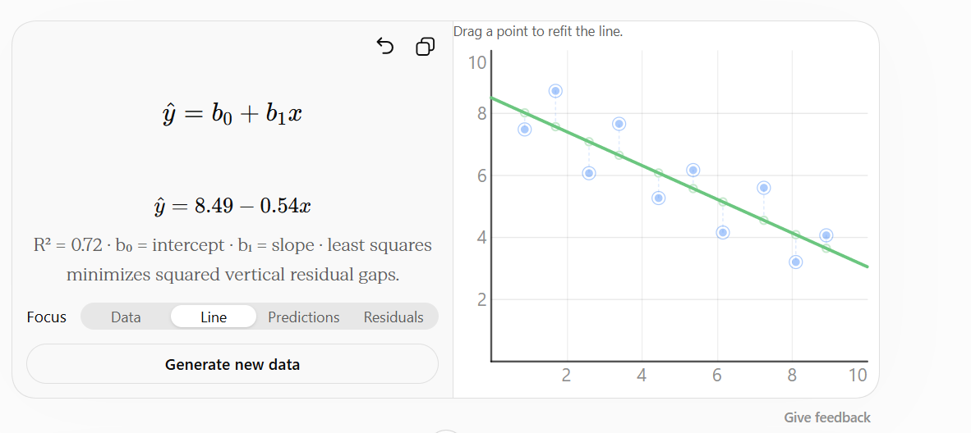
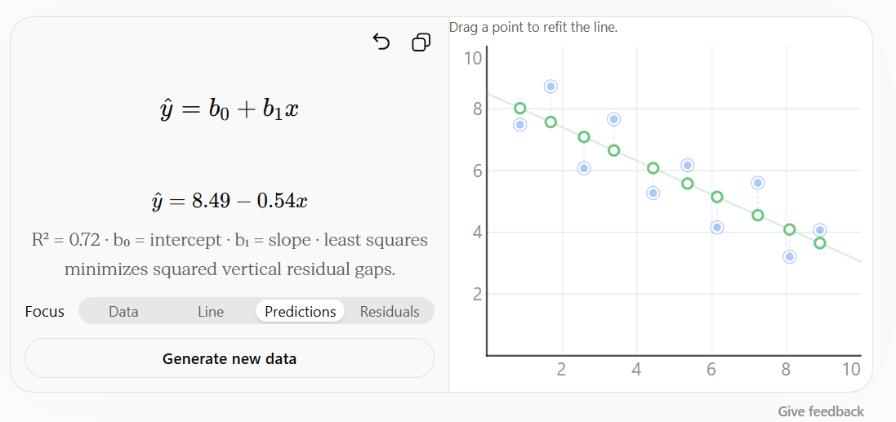
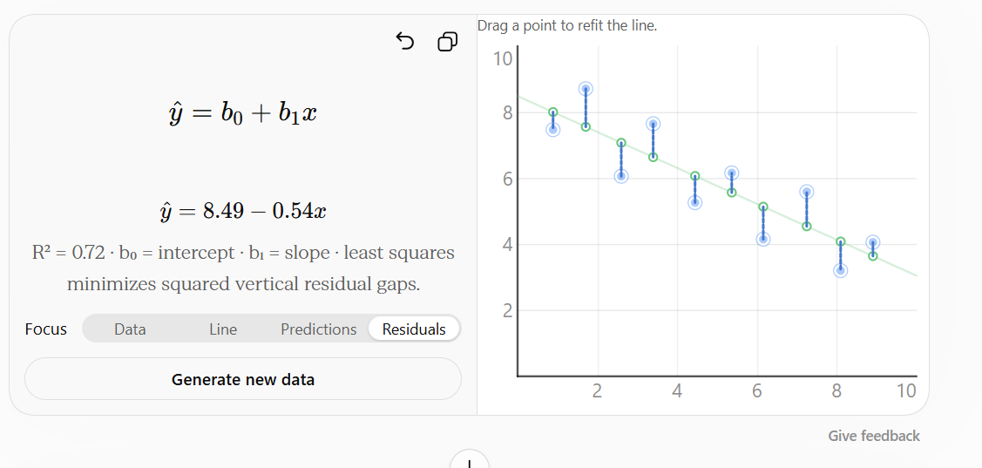

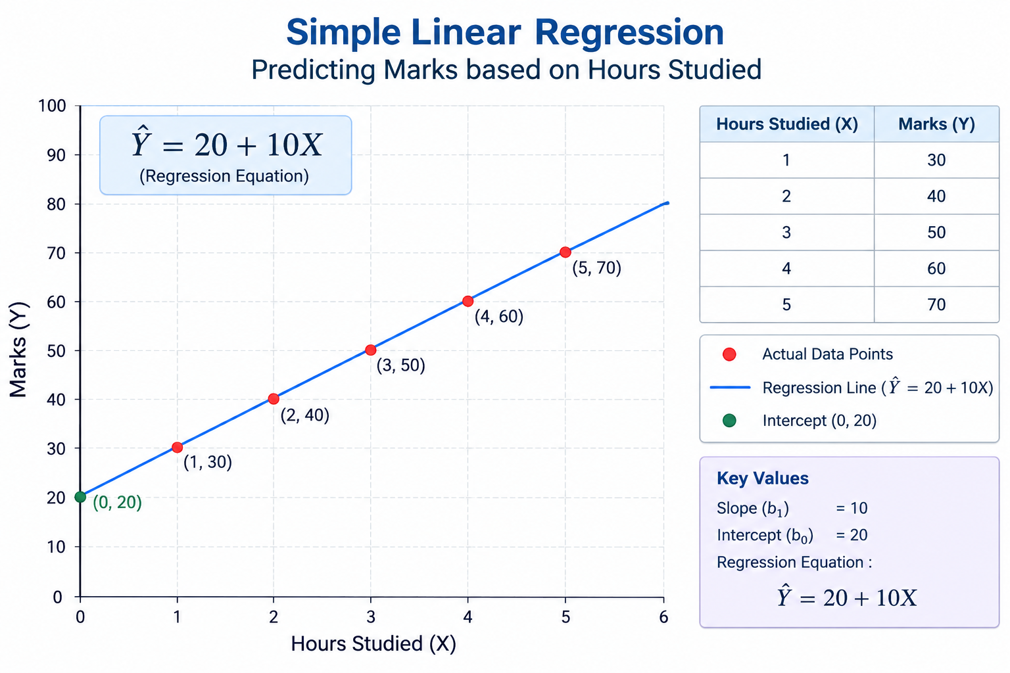 The regression line tries to stay as close as possible to all the observed points.

5. Important Terms
Independent Variable — X
The variable we use to make the prediction.
Example:
Hours studied
Dependent Variable — Y
The value we want to predict.
Example:
Marks
So:
$$X→Y$$
means:
Hours studied → Marks

6. Equation of Simple Linear Regression
The most important formula is:
$$\boxed{\hat{Y}=b_{0}+b_{1}X}$$
There are two important values to calculate:
Slope
$$\boxed{b_{1}=\frac{\sum{(}\left.X_{i}-\overline{X}\right)\left(Y_{i}-\overline{Y}\right)}{\sum{(}\left.X_{i}-\overline{X}{\left.)\right.}^{2}\right.}}$$
Intercept
$$\boxed{b_{0}=\overline{Y}-b_{1}\overline{X}}$$
Where:
- $X_{i}$= individual X value
- $Y_{i}$= individual Y value
- $\overline{X}$= mean of X
- $\overline{Y}$= mean of Y

7. Complete Numerical Example
Let's take:
X | Y
1 | 30
2 | 40
3 | 50
4 | 60
5 | 70
We want to find the regression equation.

Step 1: Find Mean of X
Formula:
$$\overline{X}=\frac{\sum{X}}{n}$$
Therefore:
$$\overline{X}=\frac{1+2+3+4+5}{5} \\ \boxed{\overline{X}=3}$$

Step 2: Find Mean of Y
$$\overline{Y}=\frac{\sum{Y}}{n} \\ \overline{Y}=\frac{30+40+50+60+70}{5} \\ \boxed{\overline{Y}=50}$$

8. Calculate Slope
Formula:
$$b_{1}=\frac{\sum{(}\left.X_{i}-\overline{X}\right)\left(Y_{i}-\overline{Y}\right)}{\sum{(}\left.X_{i}-\overline{X}{\left.)\right.}^{2}\right.}$$
Let's create a table.
X | Y | $$X-\overline{X}$$ | $$Y-\overline{Y}$$ | Product | $${\left(X-\overline{X}\right)}^{2}$$
1 | 30 | -2 | -20 | 40 | 4
2 | 40 | -1 | -10 | 10 | 1
3 | 50 | 0 | 0 | 0 | 0
4 | 60 | 1 | 10 | 10 | 1
5 | 70 | 2 | 20 | 40 | 4
Total |  |  |  | 100 | 10
Therefore:
$$b_{1}=\frac{100}{10} \\ \boxed{b_{1}=10}$$
So our slope = 10.

9. Calculate Intercept
Formula:
$$b_{0}=\overline{Y}-b_{1}\overline{X}$$
We know:
$$\overline{Y}=50 \\ b_{1}=10 \\ \overline{X}=3$$
Therefore:
$$b_{0}=50-\left(10\right)\left(3\right) \\ b_{0}=50-30 \\ \boxed{b_{0}=20}$$

10. Final Regression Equation
We have:
$$b_{0}=20$$
and
$$b_{1}=10$$
Therefore:
$$\boxed{\hat{Y}=20+10X}$$
This is our Simple Linear Regression model.

11. Prediction
Suppose a student studies for 6 hours.
So:
$$X=6$$
Our equation:
$$\hat{Y}=20+10X$$
Put $X=6$:
$$\hat{Y}=20+10\left(6\right) \\ \hat{Y}=20+60 \\ \boxed{\hat{Y}=80}$$
Therefore, predicted marks = 80.

12. Actual vs Predicted Value
Suppose actual marks were 85.
Then:
Actual:
$$Y=85$$
Predicted:
$$\hat{Y}=80$$
The difference is called Residual/Error.
$$\boxed{e=Y-\hat{Y}}$$
Therefore:
$$e=85-80 \\ \boxed{e=5}$$

13. Residual
Residual means:
$$\boxed{Residual=Actual-Predicted}$$
or:
$$\boxed{e_{i}=Y_{i}-{\hat{Y}}_{i}}$$
Example:
Actual = 85
Predicted = 80
$$e=5$$
If:
Actual = 75
Predicted = 80
$$e=75-80=-5$$
So residual can be positive or negative.

14. Why can't we simply minimize errors?
Suppose errors are:
$$+5,-5,+3,-3$$
If we simply add them:
$$5-5+3-3=0$$
It looks like there is no error, which is wrong.
Therefore, we square the errors.
$$e^{2}$$
This gives:
$$25,25,9,9$$
All values become positive.

15. Sum of Squared Errors — SSE
The formula is:
$$\boxed{SSE=\sum{(}\left.Y_{i}-{\hat{Y}}_{i}{\left.)\right.}^{2}\right.}$$
SSE means:
Sum of Squared Errors
Smaller SSE generally means the fitted line is closer to the observed data.

16. Mean Squared Error — MSE
Instead of total squared error, we can calculate average squared error.
$$\boxed{MSE=\frac{1}{n}\sum{(}\left.Y_{i}-{\hat{Y}}_{i}{\left.)\right.}^{2}\right.}$$
where $n$= number of observations.
Example:
Suppose squared errors are:
$$4,9,1,16,0$$
Then:
$$SSE=4+9+1+16+0=30$$
There are 5 observations.
$$MSE=\frac{30}{5} \\ \boxed{MSE=6}$$

17. RMSE
RMSE means:
Root Mean Squared Error
Formula:
$$\boxed{RMSE=\sqrt{MSE}}$$
If:
$$MSE=6$$
then:
$$RMSE=\sqrt{6} \\ \boxed{RMSE≈2.45}$$
Why RMSE is useful?
Because RMSE is in the same unit as Y.
If Y is marks, RMSE is also in marks.

18. MAE
Another common metric is:
Mean Absolute Error
Formula:
$$\boxed{MAE=\frac{1}{n}\sum{∣}Y_{i}-{\hat{Y}}_{i}∣}$$
Example errors:
$$5,-3,4,-2$$
Absolute errors:
$$5,3,4,2$$
Therefore:
$$MAE=\frac{5+3+4+2}{4} \\ \boxed{MAE=3.5}$$

19. Cost Function
In linear regression, we want to find the line that gives the minimum error.
A commonly used cost function is:
$$\boxed{J\left(b_{0} , b_{1}\right)=\frac{1}{2n}\sum_{i=1}^{n}{(}\left.Y_{i}-{\hat{Y}}_{i}{\left.)\right.}^{2}\right.}$$
Since:
$${\hat{Y}}_{i}=b_{0}+b_{1}X_{i}$$
we can write:
$$\boxed{J\left(b_{0} , b_{1}\right)=\frac{1}{2n}\sum_{i=1}^{n}{(}\left.Y_{i}-\left(b_{0}+b_{1}X_{i}\right){\left.)\right.}^{2}\right.}$$
The goal is:
$$\boxed{\text{Minimize }J\left(b_{0} , b_{1}\right)}$$

20. Why $1/2n$?
You may wonder why we use:
$$\frac{1}{2n}$$
instead of simply:
$$\frac{1}{n}$$
The $1/2$makes the mathematical derivative simpler because when differentiating a square:
$$\frac{d}{dx}x^{2}=2x$$
The 2 cancels with the $1/2$.
It does not change which line is the minimum.

21. Two Ways to Find the Best Line
There are two important approaches.
Method 1 — Ordinary Least Squares / Normal Equation
Directly calculate:
$$b_{1}=\frac{\sum{(}\left.X_{i}-\overline{X}\right)\left(Y_{i}-\overline{Y}\right)}{\sum{(}\left.X_{i}-\overline{X}{\left.)\right.}^{2}\right.}$$
and:
$$b_{0}=\overline{Y}-b_{1}\overline{X}$$
This is what we did above.
Method 2 — Gradient Descent
Start with some values of $b_{0}$and $b_{1}$, calculate the error, and repeatedly update them to reduce the cost.

22. Gradient Descent
The update formulas are:
$$\boxed{b_{0}:=b_{0}-α\frac{∂J}{∂b_{0}}} \\ \boxed{b_{1}:=b_{1}-α\frac{∂J}{∂b_{1}}}$$
where:
$$α$$
is called the learning rate.
The gradients are:
$$\boxed{\frac{∂J}{∂b_{0}}=-\frac{1}{n}\sum{(}\left.Y_{i}-{\hat{Y}}_{i}\right)}$$
and:
$$\boxed{\frac{∂J}{∂b_{1}}=-\frac{1}{n}\sum{X_{i}}\left(Y_{i}-{\hat{Y}}_{i}\right)}$$

23. Learning Rate
Learning rate controls how big each update is.
For example:
$$α=0.01$$
Very large learning rate
The model may jump over the minimum.
Very small learning rate
Training can become very slow.
So we need a suitable learning rate.

24. R² — Coefficient of Determination
R² tells us how well the regression model explains the variation in Y.
Formula:
$$\boxed{R^{2}=1-\frac{SSE}{SST}}$$
Where:
$$\boxed{SSE=\sum{(}\left.Y_{i}-{\hat{Y}}_{i}{\left.)\right.}^{2}\right.}$$
and:
$$\boxed{SST=\sum{(}\left.Y_{i}-\overline{Y}{\left.)\right.}^{2}\right.}$$

25. Meaning of R²
R² generally lies between 0 and 1 for standard regression settings.
Example:
$$R^{2}=0.90$$
means the model explains about:
$$\boxed{90\%}$$
of the variation in the target variable.
Important
High R² does not automatically mean the model is good for every purpose. We should also examine residuals and test performance.

26. Correlation vs Regression
These two are related but different.
Correlation
Measures the strength and direction of relationship between X and Y.
Correlation coefficient:
$$\boxed{r=\frac{\sum{(}\left.X-\overline{X}\right)\left(Y-\overline{Y}\right)}{\sqrt{\sum{(}\left.X-\overline{X}{\left.)\right.}^{2}\sum{(}\left.Y-\overline{Y}{\left.)\right.}^{2}\right.\right.}}}$$
Range:
$$-1≤r≤1$$
Regression
Used to create a model for prediction.
$$\hat{Y}=b_{0}+b_{1}X$$

27. Positive and Negative Slope
Positive slope
$$b_{1}>0$$
As X increases, Y tends to increase.
Example:
Study hours ↑ → Marks ↑
Add More
0.20.40.6−0.2−0.4−0.6−0.8−10.20.40.60.81−0.2
0,0
Give feedback
Negative slope
$$b_{1}<0$$
As X increases, Y tends to decrease.
Example:
Age of car ↑ → Resale price ↓
Add More
246810−2−4−6246810−2
0,0
Give feedback

28. Important Assumptions of Linear Regression
For simple linear regression, important assumptions include:
1. Linearity
Relationship between X and Y should be reasonably linear.
2. Independence
Observations/errors should generally be independent.
3. Homoscedasticity
The variance of errors should be reasonably constant across fitted values.
4. No extreme influential outliers
Extreme observations can strongly affect the regression line.
5. Normality of residuals
For many statistical inference procedures, residuals are assumed to be approximately normally distributed.
Note: Normal residuals are not required just to calculate a regression line or make ordinary predictions.

29. Outlier
An outlier is a data point that is very different from the others.
Example:
Hours | Marks
1 | 30
2 | 40
3 | 50
4 | 60
5 | 100
The point (5,100) may pull the regression line upward.
So outliers should be investigated rather than blindly deleted.

30. Underfitting and Overfitting
Underfitting
Model is too simple and doesn't capture the relationship.
High training error.
Overfitting
Model learns the training data too closely and performs poorly on unseen data.
Therefore, we divide data into:
Training data → learn model
Testing data → evaluate model

31. Complete Flow of Simple Linear Regression
Remember this flow:
Dataset
↓
Choose X and Y
↓
Split Train/Test
↓
Train Linear Regression
↓
Find b₀ and b₁
↓
Create equation
↓
Ŷ = b₀ + b₁X
↓
Make predictions
↓
Calculate errors
↓
Evaluate model
↓
MAE / MSE / RMSE / R²

32. All Important Formulas — Quick Revision
Regression equation
$$\boxed{\hat{Y}=b_{0}+b_{1}X}$$
Mean of X
$$\boxed{\overline{X}=\frac{\sum{X}}{n}}$$
Mean of Y
$$\boxed{\overline{Y}=\frac{\sum{Y}}{n}}$$
Slope
$$\boxed{b_{1}=\frac{\sum{(}\left.X_{i}-\overline{X}\right)\left(Y_{i}-\overline{Y}\right)}{\sum{(}\left.X_{i}-\overline{X}{\left.)\right.}^{2}\right.}}$$
Intercept
$$\boxed{b_{0}=\overline{Y}-b_{1}\overline{X}}$$
Residual
$$\boxed{e_{i}=Y_{i}-{\hat{Y}}_{i}}$$
SSE
$$\boxed{SSE=\sum{(}\left.Y_{i}-{\hat{Y}}_{i}{\left.)\right.}^{2}\right.}$$
MSE
$$\boxed{MSE=\frac{SSE}{n}}$$
RMSE
$$\boxed{RMSE=\sqrt{MSE}}$$
MAE
$$\boxed{MAE=\frac{1}{n}\sum{∣}Y_{i}-{\hat{Y}}_{i}∣}$$
Cost function
$$\boxed{J\left(b_{0} , b_{1}\right)=\frac{1}{2n}\sum{(}\left.Y_{i}-\left(b_{0}+b_{1}X_{i}\right){\left.)\right.}^{2}\right.}$$
R²
$$\boxed{R^{2}=1-\frac{SSE}{SST}}$$
SST
$$\boxed{SST=\sum{(}\left.Y_{i}-\overline{Y}{\left.)\right.}^{2}\right.}$$
Correlation
$$\boxed{r=\frac{\sum{(}\left.X-\overline{X}\right)\left(Y-\overline{Y}\right)}{\sqrt{\sum{(}\left.X-\overline{X}{\left.)\right.}^{2}\sum{(}\left.Y-\overline{Y}{\left.)\right.}^{2}\right.\right.}}}$$

🧠 One-line memory trick
Simple Linear Regression = Find the best straight line between one X and one Y, using
$$\boxed{\hat{Y}=b_{0}+b_{1}X}$$
where slope $b_{1}$tells how much Y changes when X increases by 1, and intercept $b_{0}$tells the predicted Y when X = 0.

i have one doubt that we comapre two values actual and predicted from where we get actual values as predicted are foound by trained model
Exactly! 👍 This is one of the most important concepts in machine learning.
The key point is:
Actual values do NOT come from the trained model. They come from the original real-world dataset.
Let's understand it step by step.

1. Where do Actual Values come from?
Suppose we have this dataset:
Hours Studied (X) | Actual Marks (Y)
1 | 30
2 | 40
3 | 50
4 | 60
5 | 70
These actual marks were already present in our dataset.
For example, this data could have been collected from 5 students:
Student 1 → studied 1 hour → actually got 30 marks
Student 2 → studied 2 hours → actually got 40 marks
Student 3 → studied 3 hours → actually got 50 marks
Student 4 → studied 4 hours → actually got 60 marks
Student 5 → studied 5 hours → actually got 70 marks
The machine learning model doesn't know these values by itself.

2. Then what does the model do?
We give the model the training data.
For example:
X = Hours Studied
Y = Actual Marks
The model learns the relationship between them.
It finds:
$$\hat{Y}=b_{0}+b_{1}X$$
From our example:
$$\hat{Y}=20+10X$$
Now the model can make predictions.

3. Very important: Training vs Testing
Usually we divide our dataset into:
Original Dataset
↓
┌──────────────┐
↓ ↓
Training Testing
Data Data
↓ ↓
Model Evaluate
Training Model
For example, suppose we have 10 students.
Student | Hours X | Actual Marks Y
1 | 1 | 30
2 | 2 | 40
3 | 3 | 50
4 | 4 | 60
5 | 5 | 70
6 | 6 | 80
7 | 7 | 75
8 | 8 | 90
9 | 9 | 85
10 | 10 | 95
We might split them:
Training data
Students 1–8
The model learns from these.
Testing data
Students 9–10
We keep their actual marks hidden from the model during prediction.

4. Then what happens during testing?
Suppose the test data contains:
Hours Studied | Actual Marks
9 | 85
10 | 95
The model has already learned its equation.
Suppose:
$$\hat{Y}=20+8X$$
Now give the model:
$$X=9$$
The model predicts:
$$\hat{Y}=20+8\left(9\right) \\ \hat{Y}=92$$
So we now have:
X | Actual Y | Predicted Ŷ
9 | 85 | 92
Where did 85 come from?
👉 From the original testing dataset.
Where did 92 come from?
👉 From the trained model.

5. Why do we compare them?
Because we want to know:
How well is my trained model predicting unseen data?
So:
$$Error=Actual-Predicted$$
Here:
$$Error=85-92=-7$$
The model was off by 7 marks.

6. Think of it like an exam 🎓
Imagine you are teaching a student.
Training
You give the student 8 solved examples:
1 hour → 30 marks
2 hours → 40 marks
3 hours → 50 marks
...
The student learns the pattern.
Test
Now you give:
9 hours → ?
The student says:
92 marks
But you already know the real answer from the test dataset:
Actual = 85
So you compare:
Actual Predicted
85 vs 92
That's exactly what machine learning evaluation does.

7. One very important point
During prediction, we don't give the actual Y to the model.
We give only:
$$X$$
The model produces:
$$\hat{Y}$$
Then after prediction, we compare it with the actual Y that was stored in our test dataset.
TEST DATA
┌───────────────┐
│ X Y │
│ 9 85 │
│ 10 95 │
└───────────────┘
↓
Give X only
↓
┌─────────────────┐
│ Trained Model │
└─────────────────┘
↓
Predicted Ŷ
↓
Compare with Y
↓
Calculate Error

8. What if we want to predict a completely new student?
Suppose a new student studied 12 hours.
We give:
$$X=12$$
The model predicts:
$$\hat{Y}=20+8\left(12\right)=116$$
But we don't know the actual marks yet because the student hasn't taken the exam.
So:
Hours | Actual | Predicted
12 | ❓ | 116
We cannot calculate the prediction error yet.
After the student takes the exam, suppose they actually get 100:
Hours | Actual | Predicted
12 | 100 | 116
Now we can calculate:
$$Error=100-116=-16$$

🧠 Remember this distinction
Value | Where does it come from?
X (input) | Dataset/user/new data
Y (Actual) | Real-world observed value in dataset
Ŷ (Predicted) | Trained ML model
Error | Actual − Predicted
MSE/RMSE/MAE | Calculated from actual and predicted values
The entire concept in one line:
$$\boxed{\text{Real Data gives Actual Y, trained Model gives Predicted }\overset{ˆ}{\text{Y}}}$$
Then:
$$\boxed{\text{Actual Y} vs \text{Predicted }\overset{ˆ}{\text{Y}}}$$
to determine how well the model performs.
means from whole dataset we keep 80% data as training data feed that data 80% data to model to train it and remaining 20% data is not feeded it is kept for testing and then model is tested by passing that input values which are in test data unseen to model and then that found value is predicted value and actual value is the value in dataset
Yes! Exactly right. ✅ Your understanding is correct.
The complete process is:
WHOLE DATASET
100%
│
Split the data
│
┌─────────┴─────────┐
↓ ↓
TRAINING DATA TESTING DATA
80% 20%
│ │
↓ │
Feed X + Actual Y │
to the model │
│ │
↓ │
Model learns │
relationship │
│ │
↓ ↓
TRAINED MODEL ←── Give X values
from test data
│
↓
Predicted Ŷ
│
↓
Compare with Actual Y
already present in
test dataset
│
↓
Error / MSE / RMSE / R²
Let's use our example
Whole dataset:
X (Hours) | Y (Actual Marks)
1 | 30
2 | 40
3 | 50
4 | 60
5 | 70
6 | 80
7 | 75
8 | 90
9 | 85
10 | 95
Suppose we split it:
🟢 80% Training
X | Actual Y
1 | 30
2 | 40
3 | 50
4 | 60
5 | 70
6 | 80
7 | 75
8 | 90
The model gets X and Y and learns from them.

🔵 20% Testing
X | Actual Y
9 | 85
10 | 95
These rows are not used during training.
Now we take only the X values:
X = 9
X = 10
and pass them to the trained model.
Suppose the model gives:
X | Actual Y | Predicted Ŷ
9 | 85 | 88
10 | 95 | 96
Notice:
85 and 95 = actual values from the original test dataset
88 and 96 = values produced by the trained model
Then we compare:
$$Error=Actual-Predicted$$
For X = 9:
$$85-88=-3$$
For X = 10:
$$95-96=-1$$
Then we can calculate MAE, MSE, RMSE, etc.
⭐ One small correction to your wording
You said:
"20% data is not feeded"
More precisely:
The 20% test data is not fed to the model during the training process.
Later, during testing, we feed its input X values to the trained model. We keep the actual Y values to compare against the predictions.
So remember:
$$\boxed{\text{Training: }X_{train}+Y_{train}→Model} \\ \boxed{\text{Testing: }X_{test}→Model→\hat{Y}}$$
Then:
$$\boxed{Y_{test} \left(\text{Actual}\right) vs \hat{Y} \left(\text{Predicted}\right)}$$
That is exactly how train-test evaluation works. 🎯

